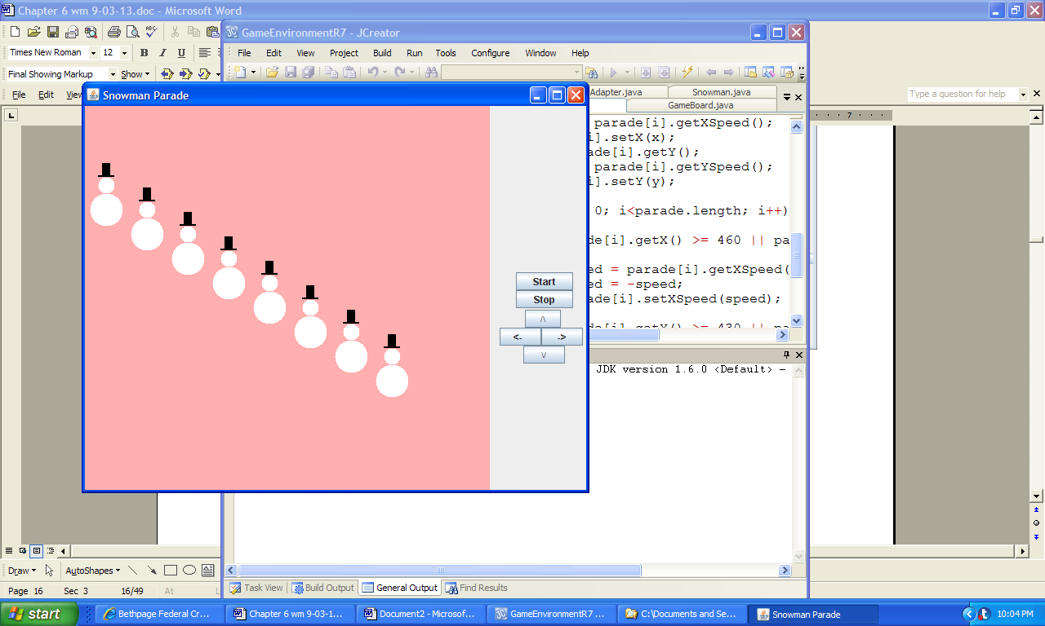 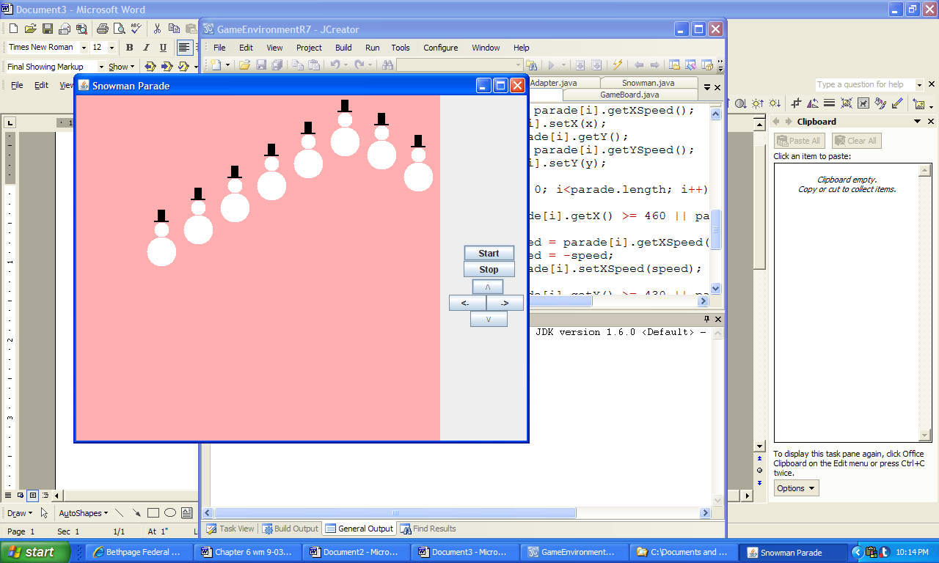

**a) Initial output b) Output several seconds after Start is clicked**

**Figure 6.10 The output of the application SnowmanParade.**